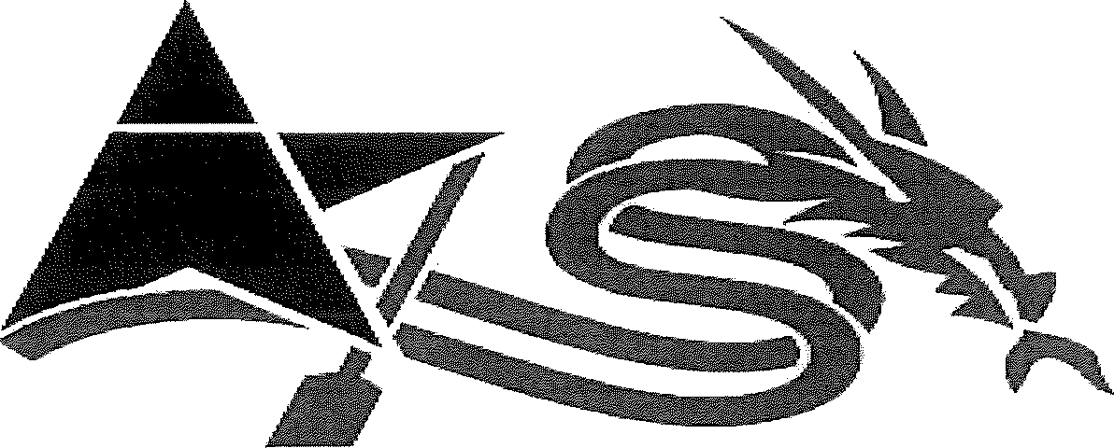

UNITED STATES DRAGON BOAT FEDERATION

AMATEUR ATHLETIC WAIVER AND RELEASE OF LIABILITY READ BEFORE SIGNING

EVENT NAME: Paddle For Pink EVENT DATE: June 18, 2016

Inconsideration of being allowed to participate in any way in the UNITED STATES DRAGON BOAT FEDERATION, (USDBF) athletic sports program, related events and activities, the undersigned acknowledges, appreciates, and agrees that: The risk of injury from the activities involved in this program is significant, including the potential for permanent paralysis and death, and while particular rules, equipment, and personal discipline may reduce this risk, the risk of serious injury does exist; and, I KNOWINGLY AND FREELY ASSUME ALL SUCH RISKS, both known and unknown, EVEN IF ARISING FROM THE NEGLIGENCE OF THE RELEASEES or other and assume full responsibility for my participation; and, I willingly agree to comply with the stated and customary terms and conditions for participation. If, however, I observe any unusual significant hazard during my presence or participation, I will remove myself from participation and bring such to the attention of the nearest official immediately; and, I, for myself and on behalf of my heirs, assigns, personal representatives and next of kin, HEREBY RELEASE AND HOLD HARMLESS the UNITED STATES DRAGON BOAT
FEDERATION, (USDBF), & Machestic Dragons, Mercer Co. Park Commission & County of Mercer, West Windsor Twp., Pan American Dragon Boat Association, LLC, ; their officers, directors, coaches, steersman, volunteers, officials, agents, and/or employees, other participants, municipalities, sponsoring agencies, sponsors, advertisers, and, if applicable, owners and lessors of premises used to conduct club & training & racing activities ("RELEASEES"), WITH RESPECT TO ANY AND ALL INJURY, DISABILITY, DEATH, or loss or damage to person or property, WHETHER ARISING FROM THE NEGLIGENCE OF THE RELEASEES OR OTHERWISE. I also acknowledge that photographs and video may be taken of me in my participation in, and attendance at this event, and hereby freely agree to allow without restriction all uses of such photos and videos in the reporting of this race, and/or in the promotion of this event, its location, other sporting events, sport in general, and/or related purposes.

I HAVE READ THIS RELEASE OF LIABILITY AND ASSUMPTION OF RISK AGREEMENT, FULLY UNDERSTAND ITS TERMS, UNDERSTAND THAT I HAVE GIVEN UP SUBSTANTIAL RIGHTS BY SIGNING IT, AND SIGN IT FREELY AND VOLUNTARILY WITHOUT ANY INDUCEMENT.

Date:

(Member Name -Please Print) (Member's Signature)

Member's Address
FOR PARTICIPANTS OF MINORITY AGE (UNDER AGE 18 AT THE TIME OF REGISTRATION)
This is to certify that I, as parent/guardian with legal responsibility for this participant, do consent and agree to his/her release as provided above, of all the Releasees, and, for myself, my heirs, assigns, and next of kin, I release and agree to indemnify and hold harmless the Releasees from any and all liabilities incident to my minor child's involvement or participation in these programs as provided above, EVEN IF ARISING FROM THE NEGLIGENCE OF THE RELEASEES, to the fullest extent permitted by law.
x -
(Parent/Guardian Signature) (Emergency phone number) Date

